# Lab: CSS In Depth

Problems for exercises and homework for the ["HTML and CSS" course @ SoftUni](https://softuni.bg/courses/web-fundamentals-html5). Submit your solutions in the SoftUni judge system at <https://judge.softuni.bg/Contests/797/Lab-CSS-In-Depth>.

1. **Plan Page**

You are given the HTML for the Web page shown below. Write the missing CSS:

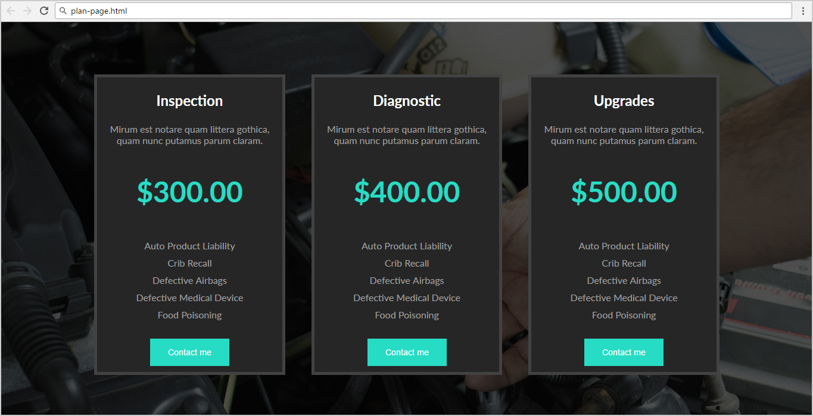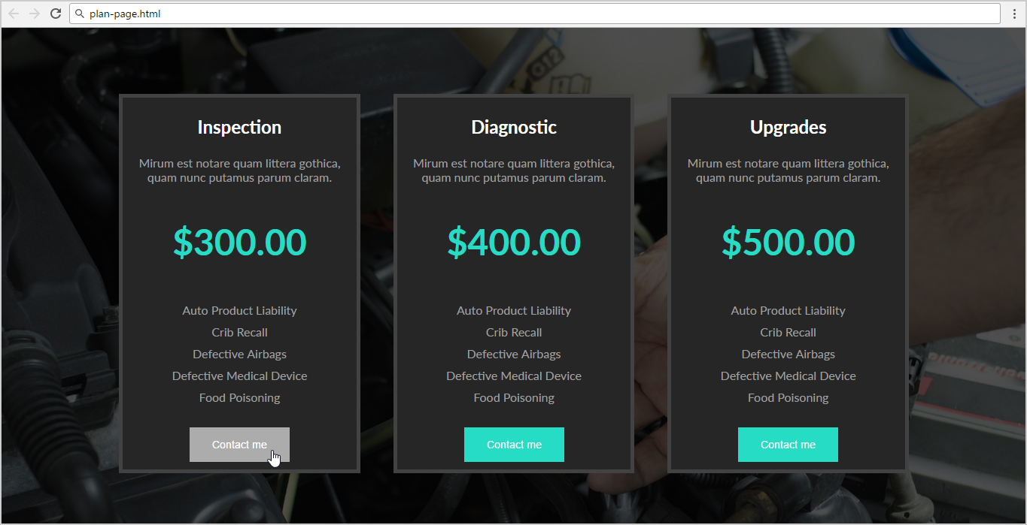

* Use the following HTML file: "**plan-page.html**".
  + You are **NOT** allowed to change the HTML code.
* Write the missing CSS file: "**plan-page.css**".

### Constrains

* **Body**
  + Font Family: **Lato, sans-serif**
  + Background: **url(plan-page.jpg)**
  + Text size: 16px
  + Width:1180px
* **Section**
  + Center the **container**
* **Article**
  + Background: **#262626**
  + Display: **inline-block**
  + Margin: **80px 20px 0 20px**
  + Border: **5px solid #424242**
  + Color: **#a1a1a1**
* **Article <h1>**
  + Text size: **1.5em**
  + Color: **#FFF**
* **<p> with class="price"**
  + Text size: **3em**
  + Text weight: **bold**
  + Color: **#27dcc4**
* **<ul>**
  + Padding: **0**
* **<button>**
  + Background: **#27dcc4**
  + Color: **#FFF**
  + Padding: **15px 30px**
  + Margin: **10px 0**
  + Text size: **0.9em**
  + Cursor: **pointer**
  + Border: **none**
* **<button> on hover**
  + Background: **#ACACAC**
* **<li>**
  + List-style-type: **none**
  + Padding: **5px 0**